**Uvod u React**

***Nikola Nikolic 2023***

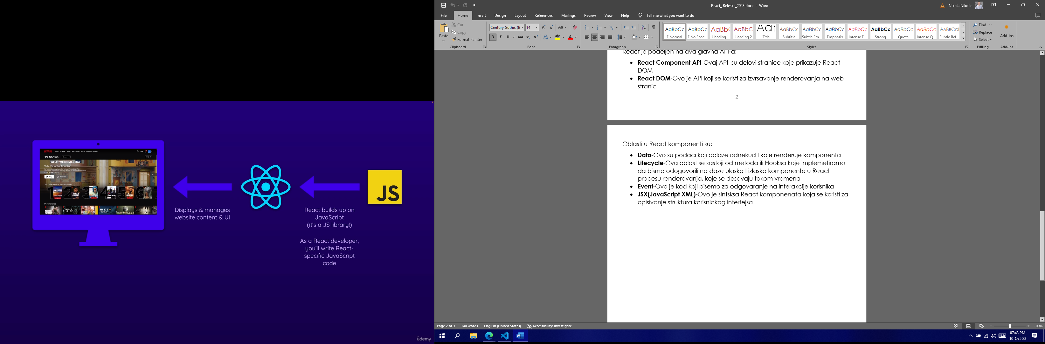

React je Javascript biblioteka za kreiranje korisnickog interfejsa(UI-a). React se smatra slojem prikaza u aplikaciji.

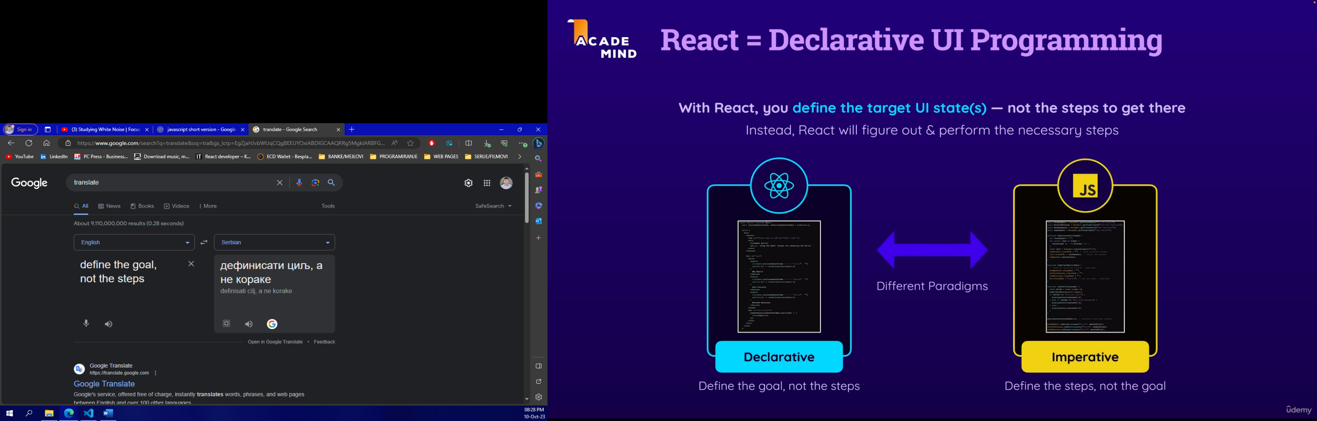

**A Closer Look: Components & File Extensions**

At this point, you've built a first custom component and you, of course, also worked with the App component.

For the moment, both components are stored in the App.jsx file (this will change later though).

.jsx is a file extension that's not supported by the browser! It's working because you're working in a React project that supports this special extension. Because this extension *"tells"* the underlying build process (which is running behind the scenes when the development server is running) that a file contains JSX code (which is also not supported by browsers).

It's important to understand that it's really just that build process that cares about this extension.

And therefore, you'll also find React projects that **don't use** .jsx but instead just .js as a file extension. And in those .js files, you'll also find JSX code. Because it simply depends on the underlying build process which extension is expected when using this JSX syntax in a file.

Since it doesn't work in the browser either way, there is no hard rule regarding this. Instead, you'll find projects that require .jsx (like the project setup we use in this course) and you'll find projects that also support .js (with JSX code inside).

I'm emphasizing this here so that you're not confused if you encounter React projects that don't use .jsx files.

In addition, you'll also find projects that require the**file extension as part of file imports** (e.g., import App from './App.jsx') and you'll find other projects that don't require this (i.e., there, you could just use import App from './App').

This, again, has nothing to do with the browser or *"standard JavaScript"* - instead it simply depends on the requirements of the code build process that's part of the project setup you chose.

**More Prop Syntaxes**

Beyond the various ways of setting and extracting props about which you learned in the previous lecture, there are **even more ways of dealing** with props.

But no worries, you'll see all these different features & syntaxes in action throughout the course!

**Passing a Single Prop Object**

If you got data that's already organized as a JavaScript object, you can pass that object as a single prop value instead of splitting it across multiple props.

I.e., instead of

1. <CoreConcept
2. title={CORE_CONCEPTS[0].title}
3. description={CORE_CONCEPTS[0].description}
4. image={CORE_CONCEPTS[0].image} />

or

1. <CoreConcept
2. {...CORE_CONCEPTS[0]} />

you could also pass a single concept (or any name of your choice) prop to the CoreConcept component:

1. <CoreConcept
2. concept={CORE_CONCEPTS[0]} />

In the CoreConcept component, you would then get that one single prop:

1. export default function CoreConcept({ concept }) {
2. // Use concept.title, concept.description etc.
3. // Or destructure the concept object: const { title, description, image } = concept;
4. }

It is entirely up to you which syntax & approach you prefer.

**Grouping Received Props Into a Single Object**

You can also pass multiple props to a component and then, in the component function, group them into a single object via JavaScript's ["Rest Property"](https://developer.mozilla.org/en-US/docs/Web/JavaScript/Reference/Operators/Destructuring_assignment#rest_property) syntax.

I.e., if a component is used like this:

1. <CoreConcept
2. title={CORE_CONCEPTS[0].title}
3. description={CORE_CONCEPTS[0].description}
4. image={CORE_CONCEPTS[0].image} />

You could group the received props into a single object like this:

1. export default function CoreConcept({ ...concept }) {
2. // ...concept groups multiple values into a single object
3. // Use concept.title, concept.description etc.
4. // Or destructure the concept object: const { title, description, image } = concept;
5. }

If that syntax is a bit confusing - worry not! You'll also see concrete examples for this syntax (and for why you might want to use it in certain situations) throughout the course!

**Default Prop Values**

Sometimes, you'll build components that may receive an optional prop. For example, a custom Button component may receive a type prop.

So the Button component should be usable either with a type being set:

1. <Button type="submit" caption="My Button" />

Or without it:

1. <Button caption="My Button" />

To make this component work, you might want to set a default value for the type prop - in case it's not passed.

This can easily be achieved since JavaScript supports default values when using object destructuring:

1. export default function Button({ caption, type = "submit" }) {
2. // caption has no default value, type has a default value of "submit"
3. }

**Component Composition**

Your task is to create a reusable Card component that takes a name prop as an input and, in addition, can be wrapped around any JSX code.

Use the already existing Card.js file to create the Card component in there. You can add the card CSS class to the main wrapping element in that component for some styling.

The name prop should be output as a title inside the Card component, the wrapped JSX code should be output below that title.

For example, the final Card component, should be usable like this:

1. <Card name="Maria Miles">
2. <p>
3. Maria is a professor of Computer Science at the University of Illinois.
4. </p>
5. <p>
6. <a href="mailto:blake@example.com">Email Maria</a>
7. </p>
8. </Card>

This should yield the following visual **output**:



*You can, but don't have to, tweak and edit the JSX code returned by the App component.*

**Configuring Event Handlers**

Your task is to **edit** the <button> in the App component such that the already defined handleCreateUser function is called with a value for name.

So you must not hard-code the value that should be assigned to user.name in the handleCreateUser function but instead pass it as a value for the name parameter when a click event on the <button> occurs.

You **don't** have to care about any value that might be entered into the <input> field - it's just there for decoration purposes.